Camille Walker: 801-979-5082

[www.mymommystyle.com](http://www.mymommystyle.com)

[mymommystyle@gmail.com](mailto:mymommystyle@gmail.com)

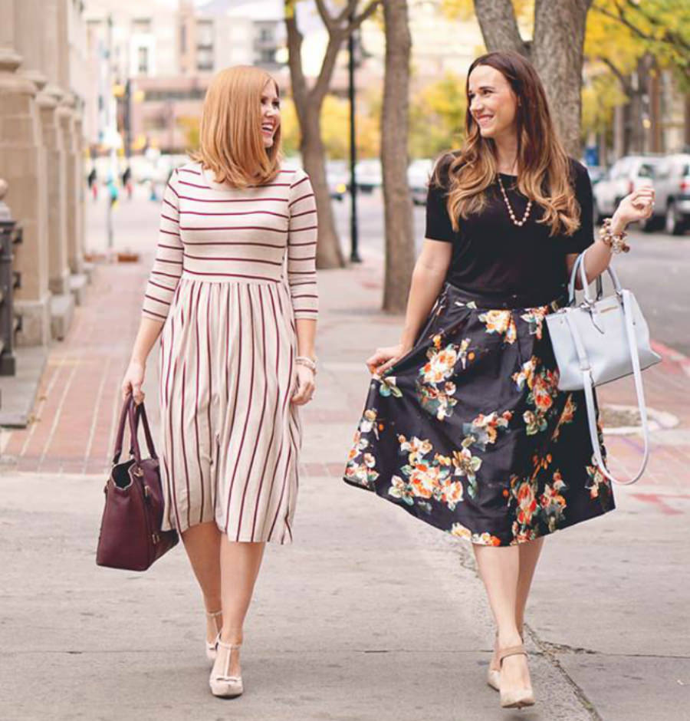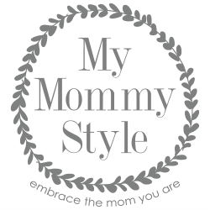

**MyMommyStyle.com Monthly Statistics**

Pageviews………………..300,000+

Unique Visitors……….200,000+

Email Subscribers….......5,000+

Our readers are well educated women ages 23-54. Most have children, with an income of $75,000-$125,000

We are Melissa & Camille, cousins, and lifelong best friends. My Mommy Style is a blog focused on motherhood and all it entails. Empowering women in their role as a mother is our passion. With eight children between us, we understand the many hats that are required as a Mom. We share **family friendly recipes, kids activities, travel, DIY, health/wellness, fashion, home décor, and parenting tips**.

**Social Media**

**105,000+**

**19,000+**

**13,500+**

**11,500+**

**700+**

Work With Us.

We love to bring quality content to our readers and interweave a brand or product we truly believe in. We accept opportunities for brand ambassadorship, social media amplification, video, and travel experiences.

We’ve had the honor of working with





